**Assignment 1**

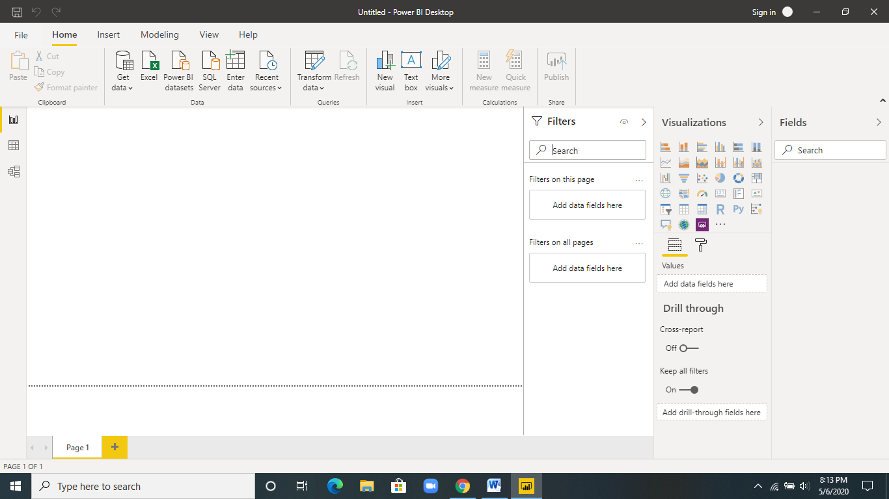

**Report View**

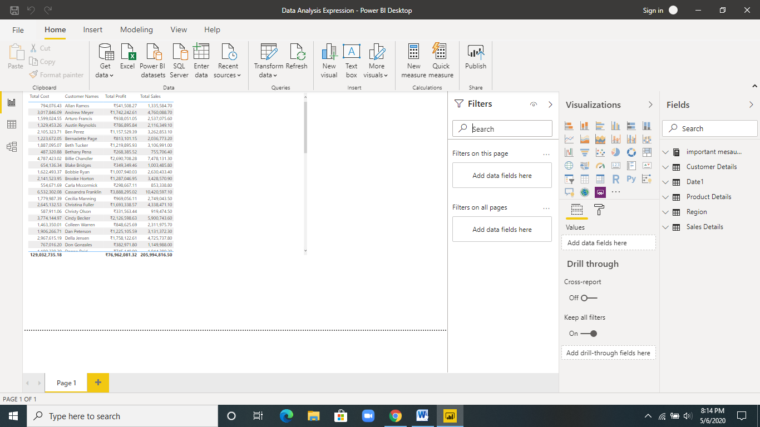

**Data View**

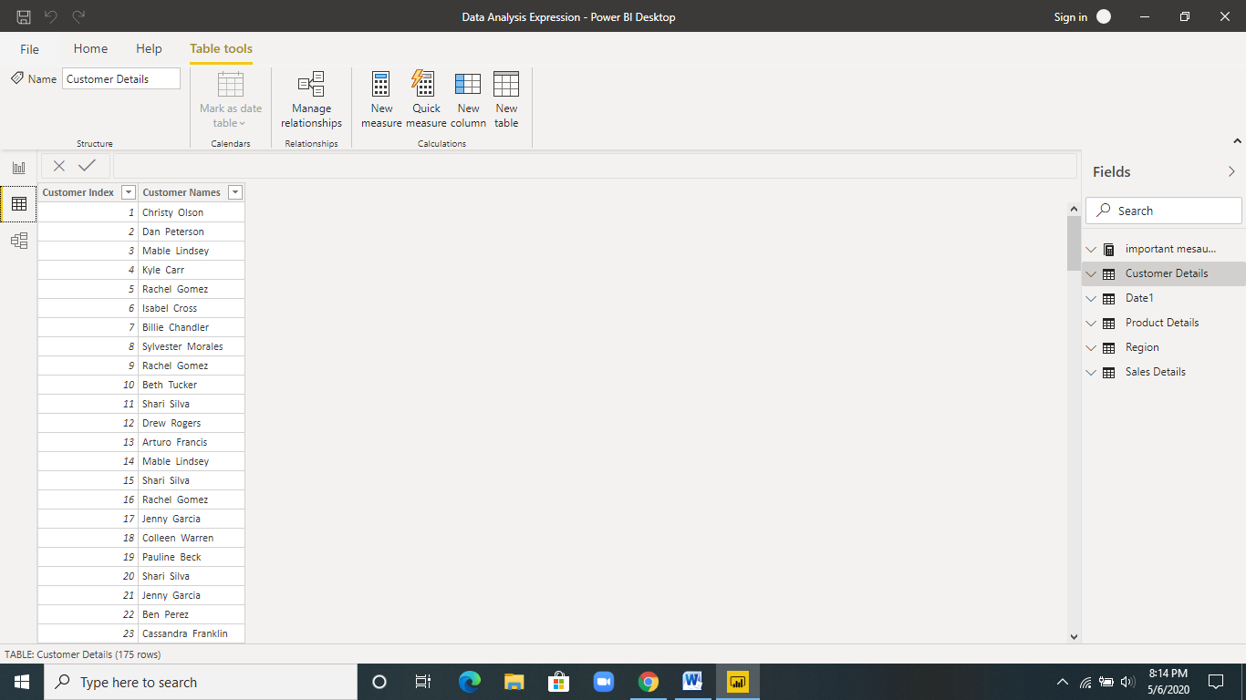

**Model View**

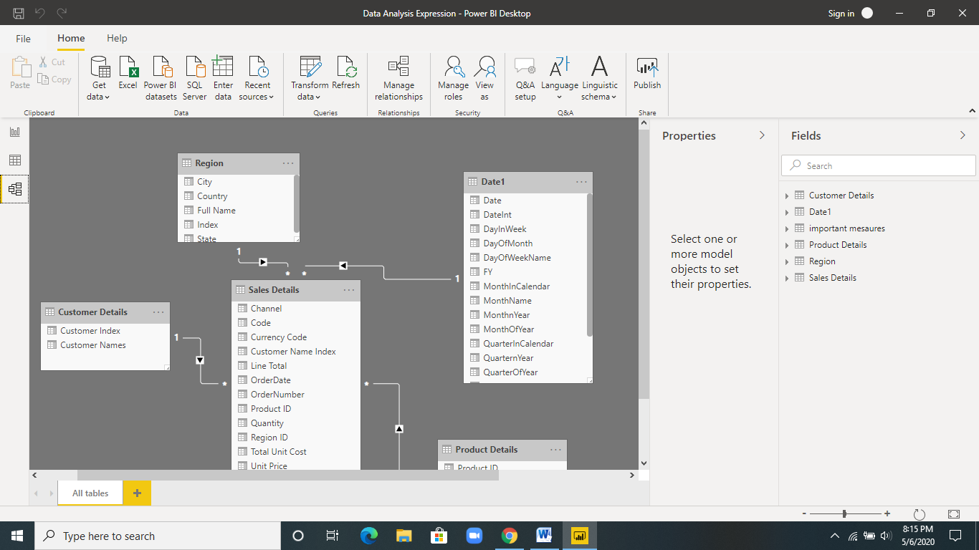

**Power Query Editor**

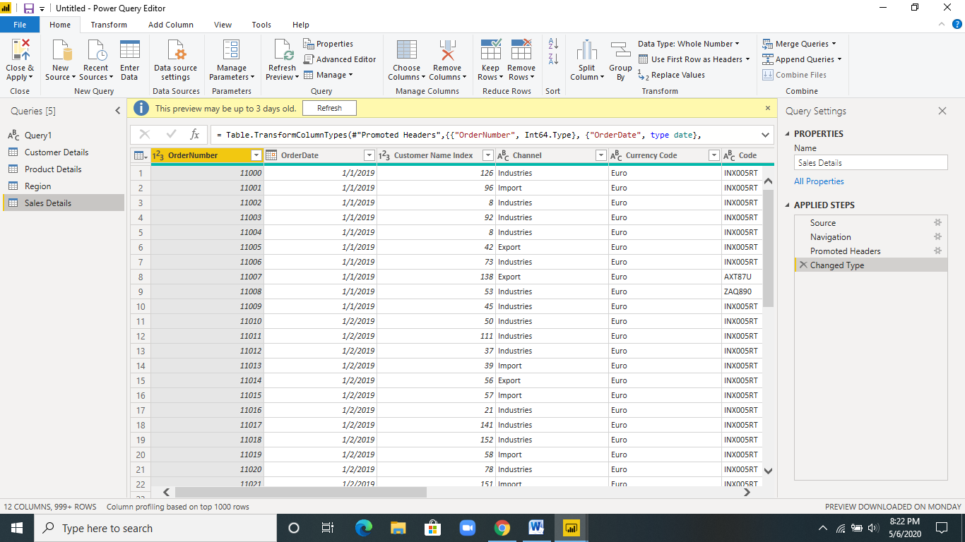

**Advance Editor:**

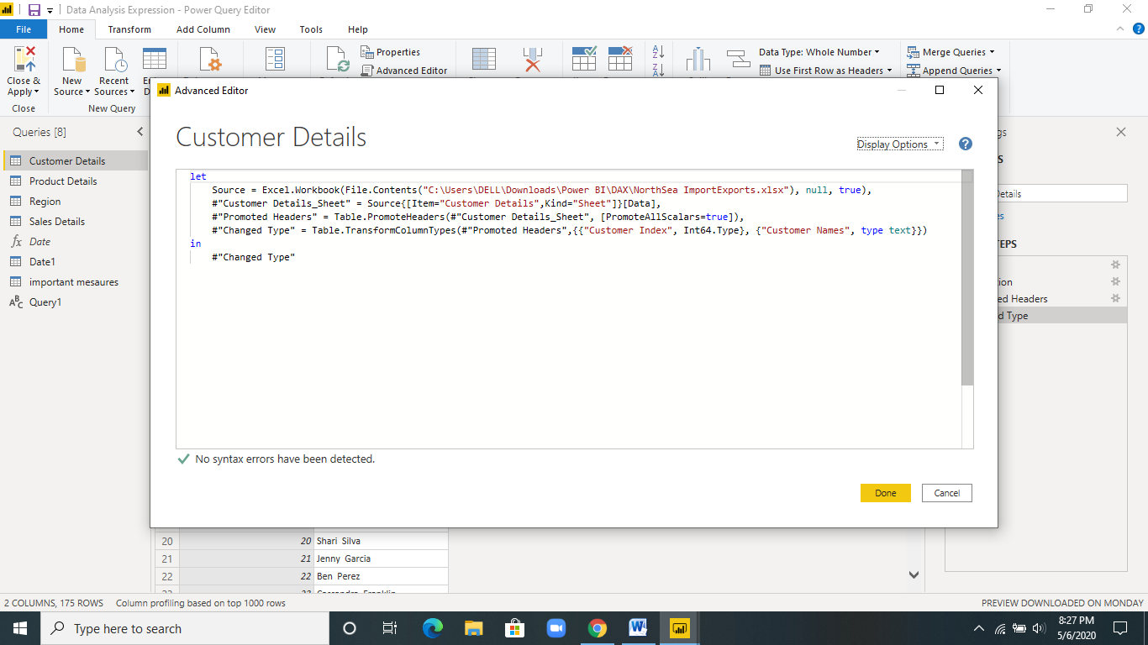

**Prepare a document with details of the following along with their price –**

Power BI Desktop – Free for community Edition

Power BI Pro – $9.99 Monthly price per user

Power BI Premium - $4,995 , Monthly price per dedicated cloud compute and storage resource with annual subscription